Guía de aprendizaje N°1 Inglés 1° Medio
Estimado alumno, debido a las actuales circunstancias y hasta que la situación se normalice, te invitamos a trabajar desde tu casa, leer esta guía e ir respondiendo las actividades propuestas. Es de suma importancia evidenciar lo que sabes y reforzar contenidos, habilidades y aprendizajes adquiridos, para que estés mejor preparado para el 1° año Medio.
El objetivo de este trabajo es reforzar aquellos contenidos primordiales para afrontar tu siguiente desafío, el año 2020.
Envía tus respuestas al correo tusguias.listal@gmail.com. Muchas gracias.

Objective: The following worksheet has been created for you to practice what you have learned in previous years.
Instructions: Do the vocabulary, grammar, reading and writing exercises. Use your knowledge and your copybook.

VOCABULARY:

- Look at the pictures and write the names of the sports:

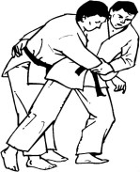
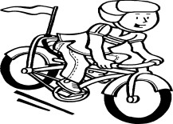
1. 2.

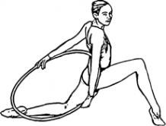
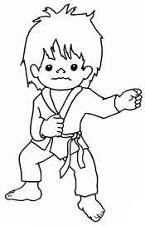
3.

5.

4.

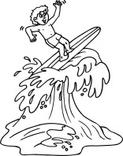
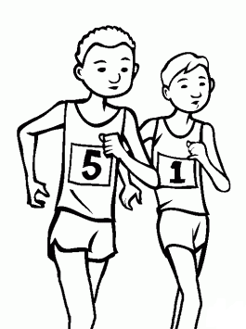
6.

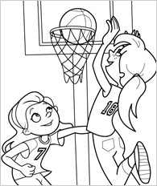
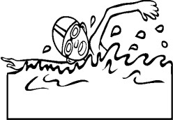
7. 8.

Read the sentences and complete with the words from the box:

Surfing karate tennis jogging basketball swimming
1. In this sport, you propel oneself through water by bodily movement.

- Stand or lie on a surfboard and ride on the crest of a wave towards the shore.

- A game played between two teams of five players in which goals are scored by throwing

a ball through a netted hoop fixed at each end of the court.

- Run at a steady, gentle pace, especially as a form of exercise.

- A game in which two players strike a hollow rubber ball with rackets over a net stretched across a grass court.

- A system of unarmed combat using the hands and feet to deliver and block blows.

Unscramble the following words:

- BKSATEBLLA :

- JGGONGI:

- JUOD:

- TNNIES:

- KTARAE:

- CIYCLNG:

- GMYASNTCIS:

d. Crossword puzzle

A. Read the sentences and write the names of the sports:

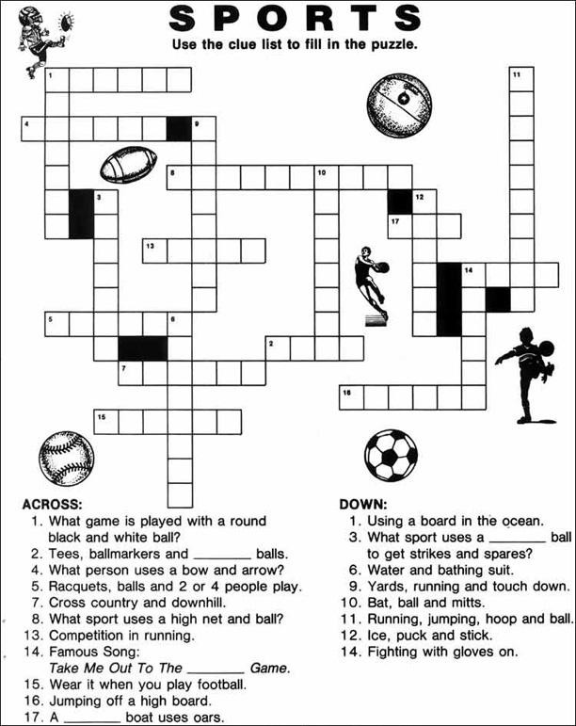

E. Complete the sentences using the verbs and sports from the box:
PLAY GO DO

- Ann cycling twice a week.

- Pablo and John judo once a week.

- Does Peter tennis every Sunday?

- Sue karate every day.

- Do Carol and her sister swimming three times a week?

- Peter doesn’t basketball every week.

- My little sister always gymnastics at school.

- Joe hardly ever surfing with his friends.

- Sonia never jogging on Sunday mornings.

- Does Paul sometimes athletics at school?

Recuerda enviar tus respuestas al correo tusguias.listal@gmail.com

Muchas gracias.

