Welding safety.
(construcciones metálicas)
Name
Grade: cuarto Medio 2020 |  | Date March 2020
Total score |  | Student’s score
Objective: Comprender y aplicar utilizando sus conocimiento previo en relación a la seguridad en un proceso de soldadura
Teacher . Miss Patricia Jara Céspedes

I: TRUE OR FALSE: Circle the correct letter.
T F 1. If an electrode sticks to the metal, free it by dipping in water.
T F 2. There is no danger to unprotected observers watching you.
T F 3. Unattended hot metal is a hazard to everyone in the laboratory.
T F 4. Welding fumes should never be allowed to collect in the laboratory.
T F 5. Electrode stubs lying on the floor are dangerous.
T F 6. Protect your face and eyes when chipping slag.
T F 7. Hot metal can be picked up with leather gloves.
T F 8. Weld with one hand to reduce fatigue.
T F 9. Wear a welding helmet with a No. 5 lens.
T F 10. It is not necessary to secure equipment in its proper place before leaving the área
T F 11. Submerge hot metal completely to prevent steam burns.
T F 12. Do not touch the electrode or electrode holder with bare hands.
T F 13. Cotton gloves and apron are the best for protecting against welding burns.
T F 14. Remove flammable materials from the welding area.
T F 15. It is safe to weld while standing on a damp floor.

II. True or False. Escriba la letra correcta a las siguiente afirmaciones presentadas abajo.
- All potential fire hazards should be removed from the welding área …………….
- Use natural drafts or fans to keep the fumes away from your face ………………..
- Eye protección is not always needed ……………….

- It is accptable to use electrode holders with loose cable connections …………..
- Electrodes should no be changed with bare hands or wet gloves …………….

III:_ Multiple choice. Analice y responda en forma segura las siguiente preguntas.

- Which part of the body is the UV light from arc welding harmful to?
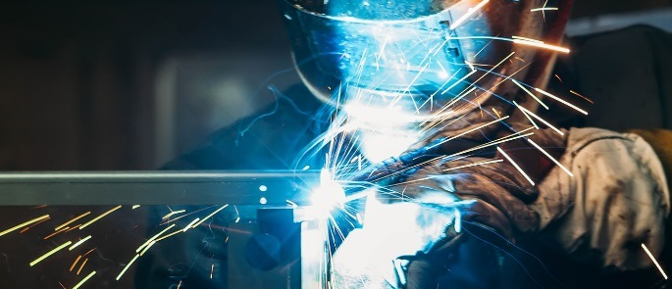
- The ears
- The forearms
- The eyes
- The hands

- Where should acetylene fuel cylinders be stored?
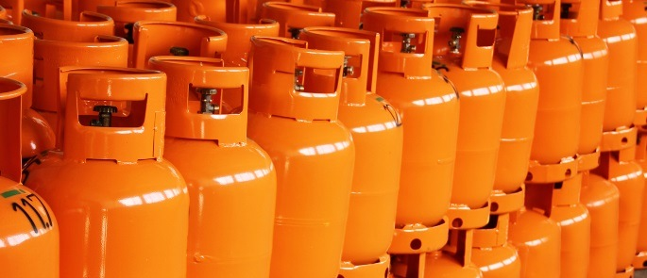
- Close to the welding area
- In a secure compound
- Alongside other gas cylinders
- In the basement

- Which of the following is an example of RPE?
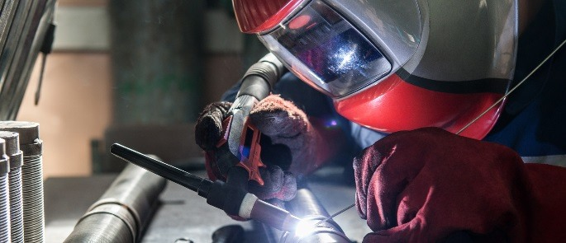
- Welding goggles or visors
- Protective gloves
- Overalls
- A disposable dust mask

- How often should welding equipment be checked for damage?
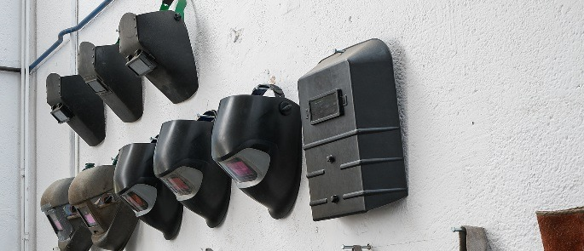
- Before every use
- On an annual basis
- Every week
- Once every few days

- Which hazardous metal oxide is associated with welding stainless steel?
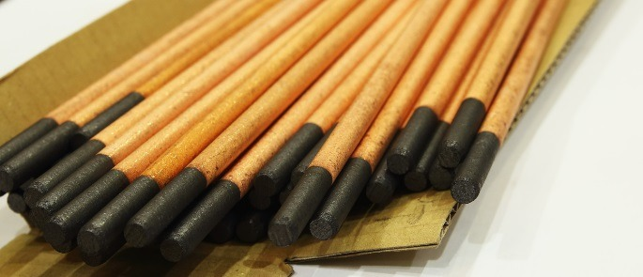
- Nitrogen oxide
- Iron oxide
- Chromium oxide
- Carbon dioxide

